Chapter 5 Notes - Population Dynamics
The total number of a ___________________ found in an area at a particular time is called a population. ______________________________ is the study of how populations change over time.

Characteristics of Populations
- _______________________________ is the range or area that a particular population inhabits
  - Ranges can vary from a __________________________ for a population of bacteria, to the millions of square kilometers occupied by ______________________ in the Pacific Ocean
- ____________________________________ is the number of individuals per _____________.
  - Let’s think about human population density
    - In _____________ in Northern Canada, humans are very sparsely (thinly) distributed. There are 31900 people living in an area of 2,038,722 km² (this is roughly the size of Western Europe). This works out to ________________ per square kilometre!
    - The Greater ___________ Area (GTA) is the largest metropolitan area in Canada, with 6,054,191 people living in 7,124.15km². This works out to ______________ per square kilometre.
    - _________, in the Philippines, is the densest city in the world, with 1,652,171 people living in only 38.55 km2. This is a density of __________________ per square kilometre!
- _____________________________________ refers to whether the population grows, shrinks, or stays roughly the same over time. The growth rate of a population is affected by ________ factors.

Four Population Growth Factors
The number of individuals in a population is affected by four major factors:
- ___________ – number of births in a year
  - Impacted by the __________ of offspring per birth, number of ___________________, and the length of ______________________
  - For humans, access to __________________ and ____________________ have a huge impact on natality
- _______________ – number of deaths in a year
  - Impacted by the average ______________ of an organism’s life, as well as its likelihood of
_______________ to adulthood
  - Also impacted by the availability of ______________, and the effects of ______________ and _____________
- ______________ – number of individuals ________________ from outside in a year
- ______________ – number of individuals ________________ of the population in a year
Open and Closed Populations
- _________________________ are affected by all of the four factors above
  - _____________________ populations are open populations – organisms can come and go as they please
- __________________________ are populations where no one leaves or moves in. Closed populations are only affected by the number of __________ and ____________
  - An isolated _________ population
  - A population in a ________ or other preserve
  - The global ____________ population
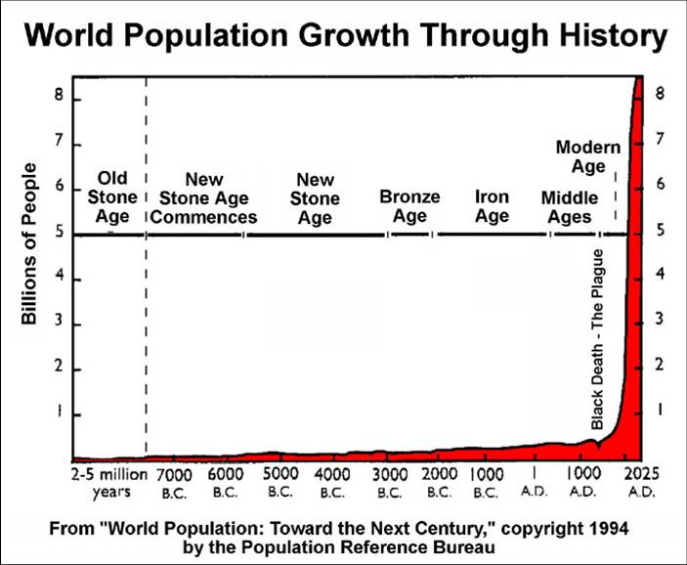
Types of Growth
- ____________________ growth (J-curve): When a population increases at a constant rate, with no slowing or levelling off.
- The __________ population of Earth has been showing exponential growth throughout the modern age
- Can this kind of growth continue forever?
    - _________. Populations will always ________ when they run out of resources

- _______________ growth (S-curve): When a population increases quickly and then the growth rate slows and the population stabilizes around the _____________________________ of the environment.
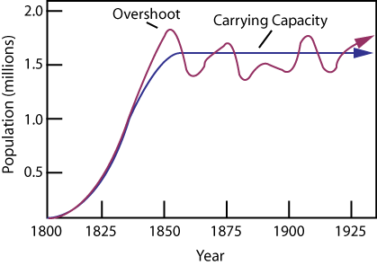
  - _______________Capacity: the maximum number of individuals of a species that can be supported indefinitely by an ecosystem.
  - An ___________ shows a population that is limited by factors such as disease, space, competition for resources, and famine.
  - Theoretically the “S-curve” is ___________, but in reality the population tends to ________________ somewhat around the carrying capacity.

David Suzuki Speaks About Overpopulation
What analogy does David Suzuki use to represent the human population of planet earth?
Summarize the situation he describes:

What type of growth is occurring in the analogy, and among humans on planet earth?____________________________
When is the test tube half full? _____________
Why is simply producing more food & resources not going to solve the problem in the long run?

What minute does Suzuki say we have already passed now? ______________

Limits to Population Growth
Populations don’t grow in __________________. The world around them impacts their ability to grow and survive. There are different ways to break down the factors that affect the size of populations. The first is Abiotic vs Biotic.
- _____________ Factors: __________________ factors that impact the size of a population
  - light, temperature, chemical environment (nutrient levels, toxin levels), water availability, weather
    - Remember limiting nutrients in aquatic ecosystems, and what happens when we add a bunch of extra nutrients by over-fertilization.
- ___________ Factors: _____________ factors that impact the size of a population
  - food, predators, diseases, parasites, competition for resources
Another way to break down these limiting factors, is by whether the factor is affected by the _____________ of individuals of the population, or whether it has the _______________________ no matter how many individuals there are. We call these Density Dependent and Density Independent factors.
Density _______________ Factors: affect members of a population _________________ of population _____________
- Examples: Fire, _________, drought, other ___________________, climate change, destruction of habitat
Density Dependent Factors: affect a population _______________ of the ____________ of the population
- Examples: _______ supply, water quality, sunlight, ____________, territory (space), predation, invasive species

Major Density-Dependent Factors:
_________________: When populations are _____________, the competition with one another for _______, _________, space, _____________, and essential ______________ becomes much more intense.
These resources get used up or blocked out more quickly when there is a large population, whereas when a population is ________, there is generally ___________ of these resources to go around.
- Remember that the populations of __________________ can also impact the availability of these resources, which can act as a selection pressure for evolutionary change (__________), and the ________________ of niches to reduce this competition.
_________________: Populations in nature are often controlled largely by their major ______________. This is known as a _______________________ relationship.
- When the population of a ______species_____________, then the predators have more food available to them, so their populations can ____________ as well. When the predator population becomes too large though, they ____________________ of the prey population sharply, and then suddenly there aren’t enough prey to sustain the large predator population, and the predators start ___________. At this point the prey species can start to increase again, and the __________ starts over.

Parasites & Disease:
- ______________ take their nourishment at the expense of their hosts, which weakens them and can cause death over time. _____________ caused by _______________ and ____________ have similar effects on the host.
- In ___________ populations of hosts, parasites and diseases are _____________________ between hosts more quickly and effectively, but they also ______________ the hosts’ ability to ___________ and __________________, which limits the growth of the host population. This in turn ____________ the populations of parasites and bacteria or viruses.
Crash Course Ecology: Population Ecology & The Texas Mosquito Mystery
(Take your own notes here)

List 3 examples of Density Independent factors from the video:___________________________________ ______________________________________________________________________________________

List 3 examples of Density Dependent factors from the video: ____________________________________ _______________________________________________________________________________________

What type of growth lead to West Nile problem in Texas?: _______________________________________

What is the formula for growth rate from the video?

Human Population Growth
Historical Human Population Size
For most of _________________, populations grew ____________________. Our populations were limited just like the populations of all other species, by major ____________________
- _________ was scarce and required time and energy (and danger from predators) to acquire, and it was very difficult to store food for very long
- Incurable _______________ were common, and accidental _____________ were often fatal
- Only about _______________________ born would survive to _______________
  - as a result, people had _______________________ to try to ensure that some would make it
Reducing the Limits on our Population Growth
Agriculture
- First started _____________________________, which allowed populations to grow somewhat larger, and allowed some specialization in society, but we were still ______________ by other factors
- More __________________ in agriculture over the _________________, including ________________ of agriculture, synthetic _______________, and more intensive _________________________ (and now even genetic modification), have provided even more food, and freed up more people to specialize in other areas of life (not everyone has to spend their lives growing food)
- Being able to __________ and ______________ food more effectively has also allowed the global population to grow.
Sanitation
- __________________ (the idea that microbes cause disease), and improvements in ______________ (_______________ systems to remove ____________________, and ___________________________ before drinking it to prevent water-borne __________________________________) have had huge impacts on _______________________ many types of disease. This has allowed the population to stay healthier, and made ___________________________________ drop dramatically
Medical Advances
- ___________________ such as emergency __________ and ____________________ to cure infections, have meant that an accidental injury or infection would ____________________ be a death sentence
- ________________ have helped to curb the spread of many disease that used to decimate populations, such as smallpox, polio, tuberculosis, measles…
- ____________________ healthcare has also helped to ensure that more people remain healthy for most of their lives.
Ecological Footprint
The _______________________ is a measure of _________________________ on the Earth’s ecosystems. It represents the amount of ______________________________ land and ocean area required to _____________________________ for a human population, and to deal with the ___________ produced by that population.
- Our ________, ____________ and ____________ consumption, ________________ and _________ habits, and the amount of __________ we produce, all impact our ecological footprint.
  - The _____________ average Ecological Footprint in 2007 was _______ hectares per person
  - The _______________ average Ecological Footprint in 2007 was ___________ hectares per person
- Scientists can use the ecological footprint of a small population to predict _______________________________ would be required if _____________________________ lived in that way.
  - If everyone on Earth lived like a ________________ we would need ______ Planet Earths to sustain us!
Crash Course Ecology: Human Population Growth
Today there are 80 year olds who have watched the population of our species ______________
R vs K Selection Theory
Describe R selected species: Describe K selected species:
Describe how we (humans) eliminated some of the obstacles in our way and raised our carrying capacity:
What are some factors that affect how much space we need to survive (ecological footprint)?
If the human population increased to 1 trillion, how much space would they get to use?
What are some reasons that the human population rate is decreasing (in some parts of the world)
Patterns of Population Growth
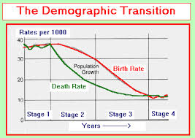
The human population ____________ continue to grow ____________________ forever, because Earth and its resources are limited. The question is, when and how will our human population growth slow? Thomas _____________ predicted (over 200 years ago) that _______, _____________, and __________ would limit the human population. Today, scientists have identified other _____________________ factors that can affect human populations as well. _______________________ is the study of ________________________, and it examines various characteristics of populations and explains ___________________________ over time. Two major factors that demographers look at are the demographic transition, and the age structure of a population.
Demographic Transition – a dramatic change in birth and death rates
- While we have ________________________ the impact of these limiting factors, causing the ___________________ to drop, in most parts of the world, ________________ remain relatively high.
- Over time though, the __________________________ leads to the _____________________________________.
  - As levels of ____________ increase and the ______________ _____________________ rises, families begin to have ___________________________ – as the birth rate drops, the number of births no longer exceed the deaths, and the population ______________________ slows or even stops.
- Population growth in the US, ________________, Japan, and _______________________ has decreased _____________________ over the past century
  - These countries have already gone through the demographic transition
  - Most countries in the world have __________________________________ the demographic transition, which is why the global population is still growing so rapidly.
    - Increases in access to ________________ and to ______________________ will be required for people in most parts of the world to complete the demographic transition
Age Structure
- Population growth also depends greatly on the _______________________ of the population – how many people in the population fall into each _________________.
- Demographers use __________________________ diagrams (also called population histograms) to analyze the structure of a population
  - These diagrams show the population of a country broken down by _______ and by __________________
  - A fairly ______________________ diagram means that the population is fairly _____________
  - A diagram shaped like a pyramid with a wide __________ means that the population is __________ rapidly
      - There are many children and teenagers, most of whom can be expected to have _____________ of their own in a few years
  - A diagram with a ____________________ than the top means that the population is ________________
      - There are _______________________ children and teenagers to reproduce in a few years, so they won’t be able to ________________ the older adults who will die over that time period

Future Population Growth
To predict how the world’s population with grow in the future; demographers must consider the _______________________ of each country, their stage in the _________________________________, and the prevalence of life-threatening ________________ such as ________, Malaria, and Cholera.
We must also ask whether the human population will continue to ______________________________, or whether it will level off into a ________________ and become more _____________. This depends on whether ________________________ move though the demographic transition quickly enough to prevent a population crash.

