**Foundations & Pre-Calculus 10**

/50

**Chapter 3 – Factoring & Polynomials – PRACTICE TEST**

Name: Date:

1. Write the prime factorization of 680. (1 mark)

2. Determine the greatest common factor of each set of numbers. (4 marks)

a) 16, 120 b) 75, 275, 450

3. Calculate the side length of the square. (2 marks) 4. Calculate the edge length of the cube. (2 marks)

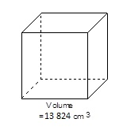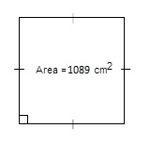

5. What pair of multiplied binomials does this set of algebra tiles represent? (2 marks)

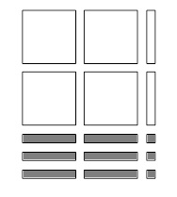

6. Which set of algebra tiles represents: $3x^{2}+4x+x$ (1 mark)

|  |  |  |  |
| --- | --- | --- | --- |
| a) |  | c) |  |
| b) |  | d) |  |

8. Factor by taking out common factors. (4 marks)



$vw-wt-w$

b) $6x^{5}-3x^{4}+9x^{3}$

|  |
| --- |
| REMEMBER: Factoring steps   1. Look for common factors first 2. Look for difference of two squares 3. Is it a trinomial? a) Perfect square trinomial? b)  (easy method)   c)  (decomposition) |

9. Factor using the difference of two squares. (4 marks)

a) b)

10. Factor using the x2 + bx + c rule. (8 marks)

a) b)

c) d)

11. Factor using the ax2 + bx + c rule (box method or decomposition). Show your work for full marks. (6 marks)

a) b)

2. Factor using any method. (16 marks)  
a) $a^{2}-20a-21$ b) $j^{2}-13j-48$

c) $49n^{2}-56n+16$ d) $400-36v^{2}$

e) $49a^{2}-9$ f) $6y^{2}-43y+20$

g) $6x^{2}+4x-16$ h) $16-34z+15$