Evolution by Natural Selection

Who Was Charles Darwin?
- Darwin was born in 1809 in England. He attended college to become a ______________ and clergyman
- When he was 22 years old he sailed on the H.M.S. ________________ as the ship’s naturalist (1831)
- He collected many animal and plant specimens from South America, documenting their diversity
- Darwin was struck by the unique animals of the ____________________________ islands in particular
Timeline of Evolutionary Thought:
- 1785 – _________________________ proposes that the Earth is shaped by geological forces that happen over long periods of time; estimates the Earth to be ___________________ (not thousands) of years old
- 1798 – Thomas ______________ writes an essay which predicts that the _______________________________ will grow faster than the space and food to sustain it
- 1809 – Jean-Baptiste ________________ publishes his hypotheses about the inheritance of ______________ traits. His ideas were flawed, but his is the first to propose a mechanisms for evolution
- 1831 – _______________ sets sail on the Beagle, a voyage that will provide evidence for his theory
- 1833 – Charles ____________ explains that _____________________________________ have changed Earth over long periods of time
- 1858 – Alfred __________________ writes to Darwin with his own speculations on ______________________ by natural selection, based on his observations in Malaysia
- 1859 – Darwin publishes his book __________________________________

Developing Darwin’s Theory:
- Suspected that living forms of similar organisms may have descended from an ancient _______________
- Different landmasses acted like isolated nurseries in which sets of species could _________________ independently
- Predicted that the 13 different species of finches on the Galapagos all evolved from a ________________ _______________________ species from South America
- Became convinced that _____________________________ could account for the location of ________________ and formation of mountains
- Figured nature must have a natural force similar to ____________________ selection
- Used information from Thomas Malthus’, Essay on the Principle of Populations, to finish his theory
- Malthus showed that all species produce far more offspring than can be expected to survive
- Darwin realized this led to an intense _______________________, he called this the theory of evolution by _____________________________________
- Alfred Russell Wallace independently arrived at the same conclusion as Darwin, while working in Malaysia

Their theory is based on 3 observations and 3 inferences:
  - Observation 1: individuals within any species exhibit __________________________________________
  - Observation 2: More offspring are produced than can ______________________
  - Observation 3: Populations tend to remain __________________
  - Inference 1: Individuals of a species are in a constant ____________________ for survival
  - Inference 2: Favourable ____________________ make individuals more likely to survive and pass on these traits. This is ____________________________________
  - Inference 3: These favourable variations will become ___________________________________ in future generations. This is ________________________
Evidence of Evolution

Evidence from Fossils:
- ________________________________ (study of fossils) has produced strong evidence for a changing earth by providing direct physical evidence of past life
Patterns found:
- 1. _____________ species are now ________________
- 2. There is a systematic progression from only very simple organisms to more _________________
ones
- 3. Living species and their most closely __________________________________ are typically located in the _____________ geographic region

Evidence from Biogeography
- Biogeography explores the ________________ and ____________________________ of life on Earth’s surface today and in the past
- ______________________________________________ has caused major changes to Earth’s landmasses
- Fossils of species from more than 150mya were once found in the _____________ geographic location
- Fossils of species __________________ than 150mya are now restricted to ______________________________ suggesting that they evolved after the breakup of the continents from the supercontinent of Pangea
- Remote islands are often home to ___________________ species suggesting that they evolved in isolation after an ancestor colonized
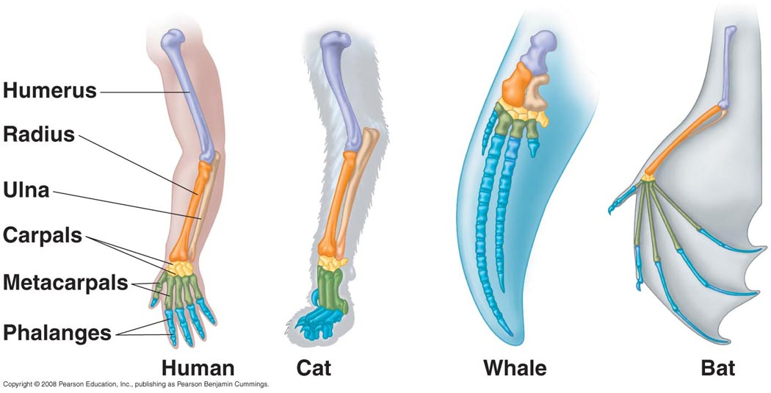
Evidence from Anatomy

- ________________________ features have similar structures but may perform very different functions.
Examples: forelimb of human, whale, cat, bat, bird…

- Embryonic development of many species also seems to indicate an evolutionary relationship
- __________________ features are rudimentary structures that serve no useful function and are usually taken as very compelling evidence for evolution. The explanation is that they must once have served a function that was beneficial
Examples:

Evidence from Artificial Selection
- Through _____________________________________ humans can produce dramatic changes in a species appearance over a relatively short period of time
Examples:
- Nature could have a similar mechanism to produce change over many ______________________________

The Process of Natural Selection
Practice Note-Taking Skills:
Watch the video “How does Evolution Really Work?” and take your own notes:

The Four Processes of Natural Selection:
- Genetic ________________
There is variation within a species, and most of this variation is inherited ____________________
- ________________________ of Offspring
Only a few offspring will survive long enough to __________________
- Struggle for ________________
There is intense competition for __________________________ such as _______, space, and __________
- Differential Survival and Reproduction
Individuals with ___________________________traits will be more likely to survive and reproduce
Over time those traits will become ____________________________ in the population

Isn’t Evolution Just a Theory?
- Yes it is a Theory. However, a theory in science is NOT a ____________________ as it would be in everyday language. We have to remember the definition of a Theory in Science:
  - Theory: An ___________________________ based on observation, experimentation, and reasoning, especially one that has been _____________________________________ as a general principle helping to explain and predict natural phenomena.

Why Does Evolution Matter Now?

- An understanding of ___________________ helps us to understand and predict how ___________________ will change due to ______________________________________________
- This can allow us to ______________ effectively to new threats and concerns.
- Example: Creating “Super Bugs” such as Multi-Drug Resistant ________________________
  - ________________________ are a powerful tool against disease, but they also act as a ________________ ________________ for the bacteria
  - Those bacteria that can ________________ the antibiotics become more common, and over time the _____________________________________________
  - The __________ and ____________ of antibiotics is causing the evolution of ______________________________ ______________ of diseases like TB
What can you do?
- Don’t use ________________________________ and products!
This just provides more ________________________ for dangerous bacteria to evolve
- If prescribed antibiotics, __________________________________________ carefully!
  - If you don’t __________________ the treatment, then some bacteria will survive and pass on their genes for better survival, making the species stronger

