**Foundations & Pre-Calculus Math 10**

**REVIEW Package for Final Exam**

**SHOW ALL WORK to RECEIVE FULL MARKS**

**Unit 2: Trigonometry (16 marks)**

1. Determine the missing angle J to the nearest tenth. (3 marks)

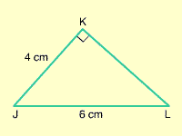

1. Find the length of side AB to the nearest tenth. (3 marks)

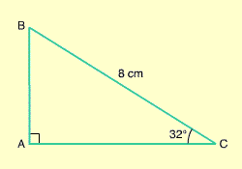

1. The side of an event tent is supported by a supportive guy wire. The wire is anchored to the ground 6 m from the base of the side of the tent. The angle of inclination of the wire is 68°. Calculate the length of the wire to the nearest tenth of a meter. (4 marks)

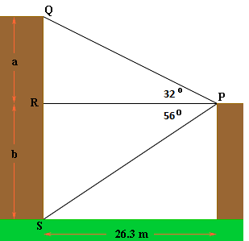

1. Two apartment towers are 26.3 m apart. From the top  
   of the shorter tower, the angle of depression of  
   the base of the taller tower is 56.7°. The angle of   
   elevation of the top of this tower is 32°.  
   Determine the difference in height of the two towers.   
   (6 marks)

**Unit 3: Polynomials (18 marks)**

1. The prime factorization of 210 is … (1 mark)

|  |  |  |  |  |  |  |  |
| --- | --- | --- | --- | --- | --- | --- | --- |
| a. | $$2∙3∙5∙7$$ | b. | $$5∙6∙7$$ | c. | $$3^{2}∙5∙7$$ | d. | $$2∙5∙21$$ |

1. Determine the greatest common factor of 56 and 84. (1 mark)

|  |  |  |  |  |  |  |  |
| --- | --- | --- | --- | --- | --- | --- | --- |
| a. | 77 | b. | 616 | c. | 7 | d. | 8 |

1. Determine the square root of 360 000. (1 mark)

|  |  |  |  |  |  |  |  |
| --- | --- | --- | --- | --- | --- | --- | --- |
| a. | 100 | b. | 36 | c. | 600 | d. | 200 |

1. Use Algebra tiles to Multiply 4x (3x + 2) (3 marks)
2. Expand (x – 2)(x + 8) (2 marks)

1. Factor 16 + 32r + 25r2 (2 marks)

1. Factor 2x2 – 30x + 72 (3 marks)

1. Factor 12x2 – 48y2 (2 marks)

1. Factor 6y2 – 25y + 14 (3 marks)

**Unit 4: Radicals & Exponents (18 marks)**

1. Which of these numbers is irrational? (1 mark)

|  |  |  |  |  |  |  |  |
| --- | --- | --- | --- | --- | --- | --- | --- |
| a. | -66 | b. | $$\sqrt[3]{27}$$ | c. | $$\sqrt{19}$$ | d. |  |

1. Evaluate ${\left(\frac{3}{2}\right)}^{-3}$ (1 mark)

|  |  |  |  |  |  |  |  |
| --- | --- | --- | --- | --- | --- | --- | --- |
| a. | $$-\frac{27}{8}$$ | b. | $$-\frac{8}{27}$$ | c. | $$\frac{27}{8}$$ | d. | $$\frac{8}{27}$$ |

1. Evaluate $\sqrt[3]{2197}$ (2 marks)
2. Write $\sqrt{162}$ in simplest form. (2 marks)
3. Write  as an entire radical. (1 mark)
4. Evaluate ${216}^{\frac{1}{3}}$ without using a calculator. Show your work. (2 mark)
5. Evaluate  (3 marks)
6. Evaluate 5-2 without using a calculator = show your work. (1 mark)
7. Simplify $\frac{\left(4^{-3}\right)\left(4^{8}\right)}{4}$ by writing as a single power. (2 marks)
8. Simplify $\frac{{\left(x^{4}{ y}^{-2}\right)}^{-1}}{{\left(x{ y}^{3}\right)}^{2}}$ (3 marks)

**Unit 5: Linear Relations & Functions (20 marks)**

1. Consider the relation represented by this arrow diagram. Represent the relation as a set of ordered pairs. (1 mark)

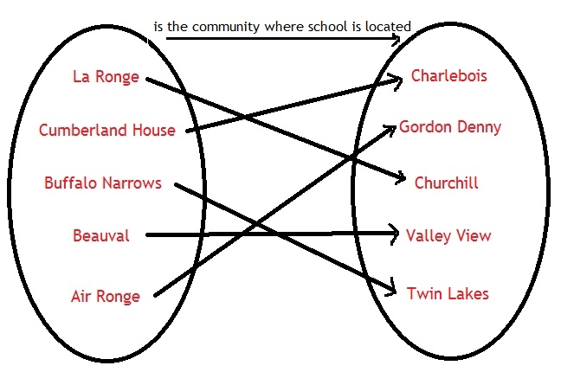

|  |  |
| --- | --- |
| a. | {(La Ronge, Charlebois), (Cumberland House, Gordon Denny), (Buffalo Narrows, Churchill), (Beauval, Valley View), (Air Ronge, Twin Lakes)} |
| b. | {(La Ronge, Churchill), (Cumberland House, Charlebois), (Buffalo Narrows, Twin Lakes), (Beauval, Valley View), (Air Ronge, Gordon Denny)} |
| c. | {(Charlebois, La Ronge), (Gordon Denny, Cumberland House), (Churchill, Buffalo Narrows), (Valley View , Beauval), (Twin Lakes , Air Ronge)} |
| d. | {(La Ronge, Twin Lakes), (Cumberland House, Valley View), (Buffalo Narrows, Churchill), (Beauval, Gordon Denny), (Air Ronge, Charlebois)} |

1. Consider the relation represented by this graph. Represent the relation as a table. (1 mark)



|  |  |  |  |
| --- | --- | --- | --- |
| a. |  | c. |  |
| b. |  | d. |  |

1. Identify the domain of this relation. (1 mark)



|  |  |  |  |
| --- | --- | --- | --- |
| a. |  | c. |  |
| b. |  | d. |  |

1. Which set of ordered pairs does not represent a function? (1 mark)

a. 

b. 

c. 

d. 

1. Each point on this graph represents a person. Which two people are the same height? (1 mark)

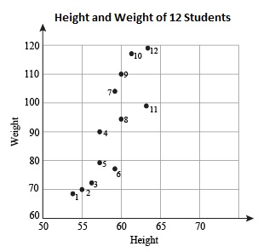

|  |  |  |  |
| --- | --- | --- | --- |
| a. | 1 and 2 | c. | 10 and 12 |
| b. | 2 and 3 | d. | 8 and 9 |

1. Identify the range of this relation. (1 mark)



|  |  |  |  |
| --- | --- | --- | --- |
| a. |  | c. |  |
| b. |  | d. |  |

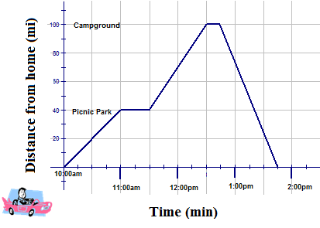

**Use the graph to answer questions 30-32.**

1. Fill in the chart below to describe all four segments of the graph. (8 marks)

|  |  |  |  |
| --- | --- | --- | --- |
| **Line Segment** | **Description of Slope** | **Actual Slope** | **Describe Scenario** |
|  | Moderate increase |  | They drove straight to the park from home |
| 11-11:30 |  |  |  |
|  |  |  |  |
| 12:45-1:45 |  |  |  |

1. About how long does it take to get to the campground from the park? (1 mark)

|  |  |  |  |  |  |  |  |
| --- | --- | --- | --- | --- | --- | --- | --- |
| a. | 15 min. | b. | 43 min. | c. | 95 min. | d. | 1. min. |

32. Which segment of the graph best describes the time spent at the campground? (1 mark)

|  |  |  |  |  |  |  |  |
| --- | --- | --- | --- | --- | --- | --- | --- |
| a. | 10-11 | b. | 11-12:30 | c. | 12:30-12:45 | d. | 12:45-2 |

1. 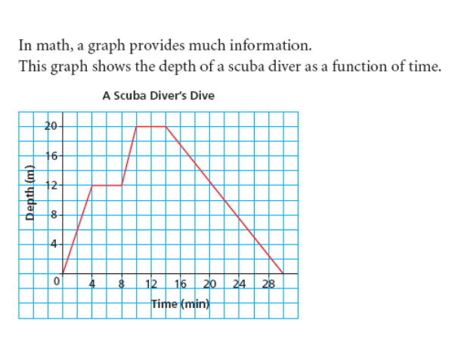Determine the domain of the graph. (1 mark)

|  |  |  |  |
| --- | --- | --- | --- |
|  |  |  |  |
|  |  |  |  |

1. This table of values represents a linear relation. Determine the rate of change (slope) of the relation.

(1 mark)

|  |  |  |  |  |  |
| --- | --- | --- | --- | --- | --- |
| **x** | 0 | 1 | 2 | 3 | 4 |
| **y** | 0 | 15 | 30 | 45 | 60 |

1. This graph shows distance, *d* kilometers, as a function of time, *t* minutes. Determine the vertical and horizontal intercepts (the x-intercept and y-intercept). (1 mark)

1. Which graph represents the linear function **y = -3x + 4** ? (1 mark)

|  |  |  |  |
| --- | --- | --- | --- |
| a. |  | c. |  |
| b. |  | d. |  |

**Unit 6: Linear Functions (15 marks)**

1. Determine the slope of this line segment. (1 mark)



|  |  |  |  |  |  |  |  |
| --- | --- | --- | --- | --- | --- | --- | --- |
| a. |  | b. |  | c. |  | d. |  |

1. Determine the slope of the line that passes through G(3, –3) and H(–5, 9). (2 marks)

|  |  |  |  |  |  |  |  |
| --- | --- | --- | --- | --- | --- | --- | --- |
| a. |  | b. |  | c. |  | d. |  |

1. The slope of a line is $\frac{34}{22}$. What is the slope of a line that is parallel to this line? (1 mark)

|  |  |  |  |  |  |  |  |
| --- | --- | --- | --- | --- | --- | --- | --- |
| a. |  | b. |  | c. |  | d. | – |

1. The slope of a line is $-\frac{2}{3}$. What is the slope of a line that is perpendicular to this line? (1 mark)

|  |  |  |  |  |  |  |  |
| --- | --- | --- | --- | --- | --- | --- | --- |
| a. | – | b. | – | c. |  | d. |  |

1. Which equation best describes this graph. (2 marks)



|  |  |  |  |
| --- | --- | --- | --- |
| a. |  | c. |  |
| b. |  | d. |  |

1. Which graph represents the equation  ******? (2 marks)

|  |  |  |  |
| --- | --- | --- | --- |
| a. | c.      b. d. |  |  |

1. Draw the graph represented by the equation **4x + 2y = 8** (6 marks)

|  |  |  |  |  |  |  |  |  |  |  |  |  |  |  |  |  |  |  |  |  |
| --- | --- | --- | --- | --- | --- | --- | --- | --- | --- | --- | --- | --- | --- | --- | --- | --- | --- | --- | --- | --- |
|  |  |  |  |  |  |  |  |  |  |  |  |  |  |  |  |  |  |  |  |  |
|  |  |  |  |  |  |  |  |  |  |  |  |  |  |  |  |  |  |  |  |  |
|  |  |  |  |  |  |  |  |  |  |  |  |  |  |  |  |  |  |  |  |  |
|  |  |  |  |  |  |  |  |  |  |  |  |  |  |  |  |  |  |  |  |  |
|  |  |  |  |  |  |  |  |  |  |  |  |  |  |  |  |  |  |  |  |  |
|  |  |  |  |  |  |  |  |  |  |  |  |  |  |  |  |  |  |  |  |  |
|  |  |  |  |  |  |  |  |  |  |  |  |  |  |  |  |  |  |  |  |  |
|  |  |  |  |  |  |  |  |  |  |  |  |  |  |  |  |  |  |  |  |  |
|  |  |  |  |  |  |  |  |  |  |  |  |  |  |  |  |  |  |  |  |  |
|  |  |  |  |  |  |  |  |  |  |  |  |  |  |  |  |  |  |  |  |  |
|  |  |  |  |  |  |  |  |  |  |  |  |  |  |  |  |  |  |  |  |  |
|  |  |  |  |  |  |  |  |  |  |  |  |  |  |  |  |  |  |  |  |  |
|  |  |  |  |  |  |  |  |  |  |  |  |  |  |  |  |  |  |  |  |  |
|  |  |  |  |  |  |  |  |  |  |  |  |  |  |  |  |  |  |  |  |  |
|  |  |  |  |  |  |  |  |  |  |  |  |  |  |  |  |  |  |  |  |  |
|  |  |  |  |  |  |  |  |  |  |  |  |  |  |  |  |  |  |  |  |  |
|  |  |  |  |  |  |  |  |  |  |  |  |  |  |  |  |  |  |  |  |  |
|  |  |  |  |  |  |  |  |  |  |  |  |  |  |  |  |  |  |  |  |  |
|  |  |  |  |  |  |  |  |  |  |  |  |  |  |  |  |  |  |  |  |  |
|  |  |  |  |  |  |  |  |  |  |  |  |  |  |  |  |  |  |  |  |  |

**Unit 7: Linear Systems (15 marks)**

42. Solve this linear system by graphing. (5 marks)





1. Solve this linear system using substitution. (5 marks)

3x + 4y = - 4  
 x +2y= 2

1. Solve this linear system using elimination. (5 marks)

2x – 4y = 7

-4x – y = -5

**Foundations & Pre-Calculus Formulas**

**Formulas**

Arectangle =

Atriangle = SOH CAH TOA $m=\frac{y_{2}-y_{1}}{x_{2}-x_{1}}$

Acircle = y = mx + b

SAcone = Ax + By + C = 0

SAsphere = y – y1 = m(x – x1)

Vprism or cylinder =

Vpyramid or cone =

Vsphere =